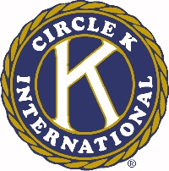
The 46th Annual Ohio District Circle K Convention

Kenneth E. Weeks Award for Outstanding Kiwanian

Name of Circle K Club______________________________

Name of Kiwanian being nominated__________________________________

This award is given to the Kiwanian who has contributed the most to the growth, achievement, and ideals of Circle K. The Ohio District Executive Board will base their decision on the following criteria:

- Relationship of the Kiwanian to the nominating Circle K Club.

- 2. Number of Circle K functions the Kiwanian has attended at the club, District, and International
level.

- Average hours devoted per week toward Circle K.

- Accomplishment in increasing Circle K – Kiwanis relations.

